Metohod POST <http://localhost:8000/users>

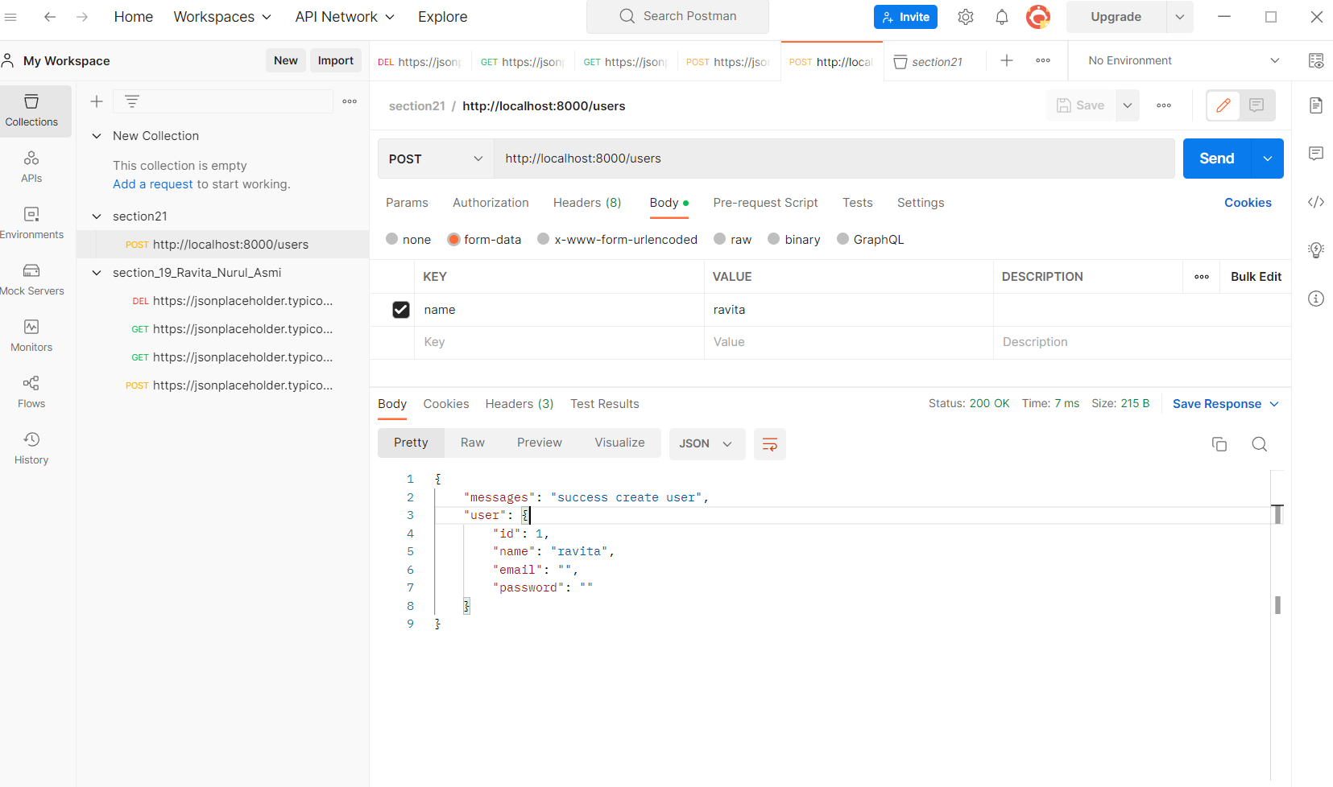

Method GET <http://localhost:8000/users>

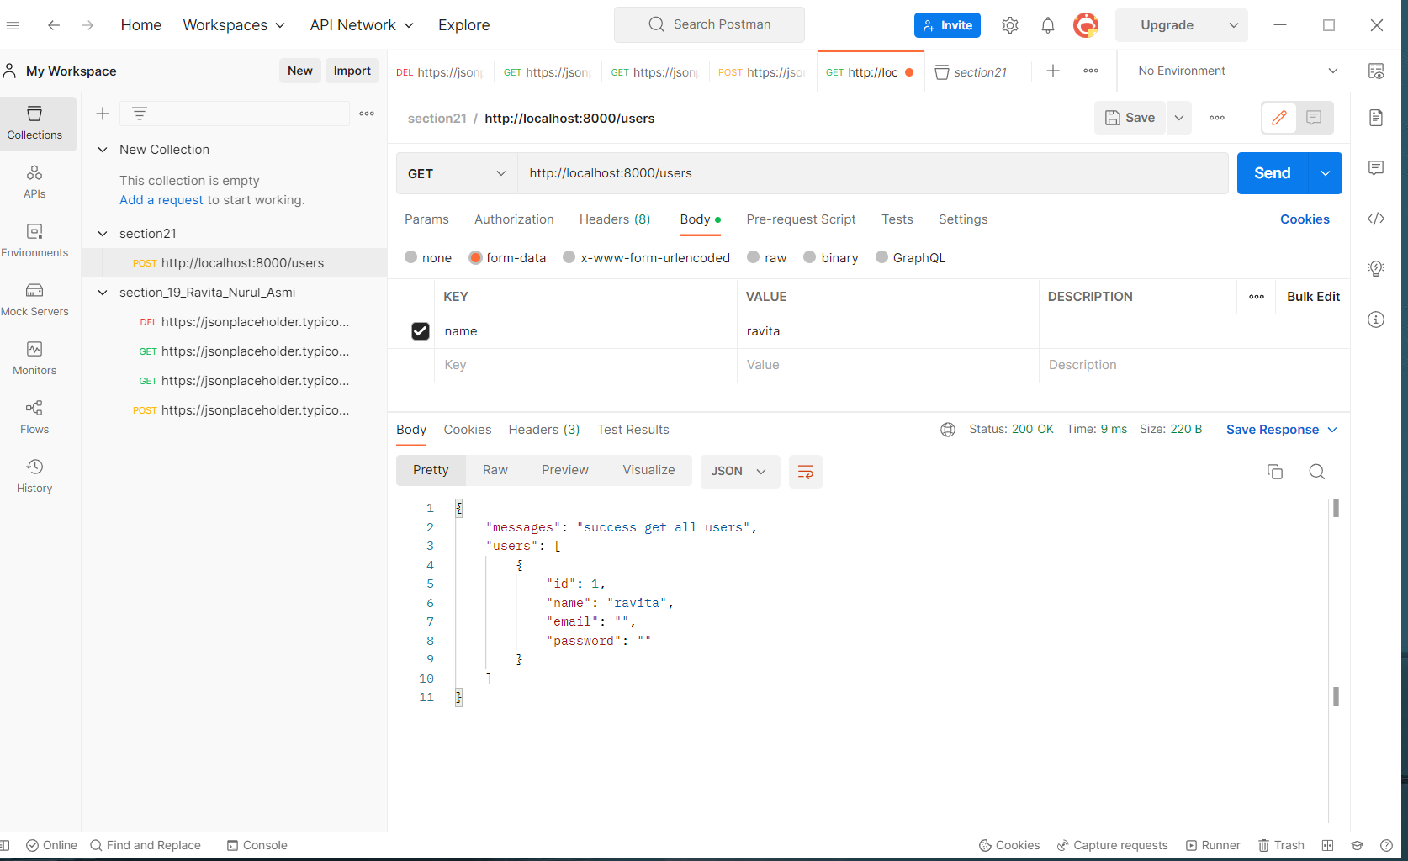

Method GET

<http://localhost:8000/users/1>

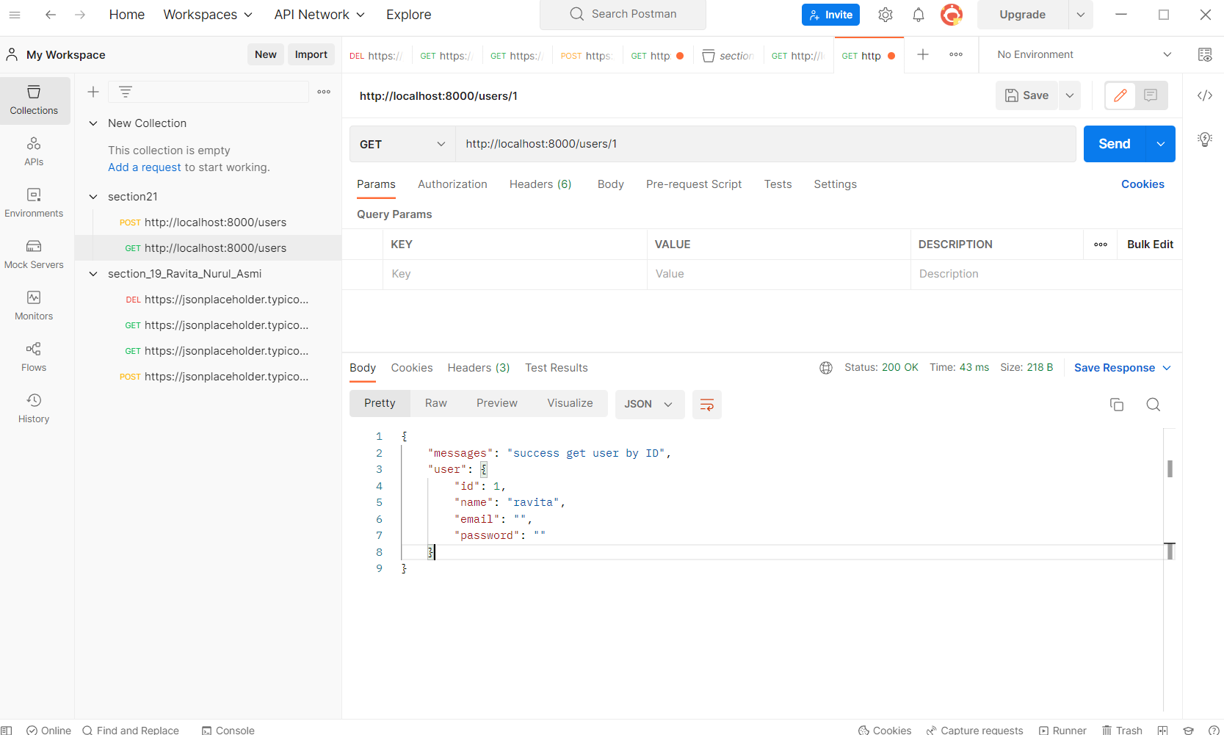

Method PUT

<http://localhost:8000/users/1>

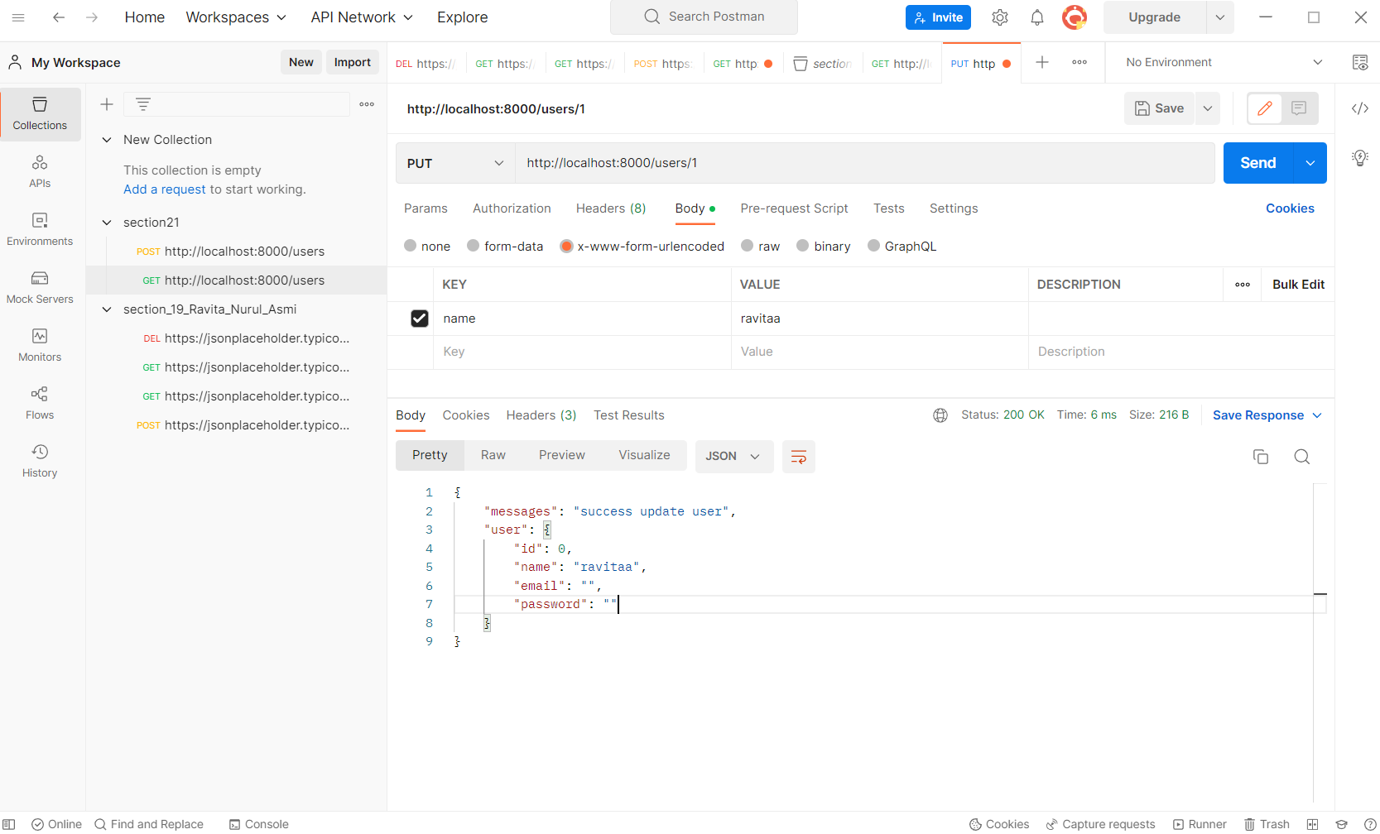

Method DELET <http://localhost:8000/users/1>

